Order Of Service

Singing: Psalm 51b—CW page 87

Reading: Psalm 147

Opening Hymn: TLH 293

Reading: I Corinthians 2:6-16

Request Hymn: CW Supplement 752

Reading: Matthew 26:1-5

Sermon Hymn: TLH 296

Sermon Text: Luke 8:16-21

The Rich Get Richer

Prayer

The Apostles’ Creed, TLH page 12

Holy Communion

The Lord's Prayer

The Blessing

Closing Hymn: TLH 285

* * * * * * * * * * *

Bible Study: Lambs: American Egret
Sheep: Proverbs 30:29-33


Hawk Ridge, Duluth MN

Water
Of
Life

11 July 2021

W A T E R O F L I F E

Independent Christian Church—Conservative Lutheran Doctrine

Worship Service: 9:30 a.m. Bible Study: 10:45 a.m.

Larry Cooper, Pastor E-Mail address:
111 N. Ridge Road lcooper@wateroflife.cc
Coon Valley, WI 54623 Web Site:
www.wateroflife.cc

* * * * * * * * * * * * * * * * * * * * * * * * * * *

Sermon Text: Luke 8:16-21

The Rich Get Richer

* * * * * * * * * * * * * * * * * * * * * * * * * * *

Luke 8:16 No man, when he hath lighted a candle, covereth it with a vessel, or putteth it under a bed; but setteth it on a candlestick, that they which enter in may see the light.
:17 For nothing is secret, that shall not be made manifest; neither any thing hid, that shall not be known and come abroad.
:18 Take heed therefore how ye hear: for whosoever hath, to him shall be given; and whosoever hath not, from him shall be taken even that which he seemeth to have.
:19 Then came to him his mother and his brethren, and could not come at him for the press.
:20 And it was told him by certain which said, Thy mother and thy brethren stand without, desiring to see thee.
:21 And he answered and said unto them, My mother and my brethren are these which hear the word of God, and do it.

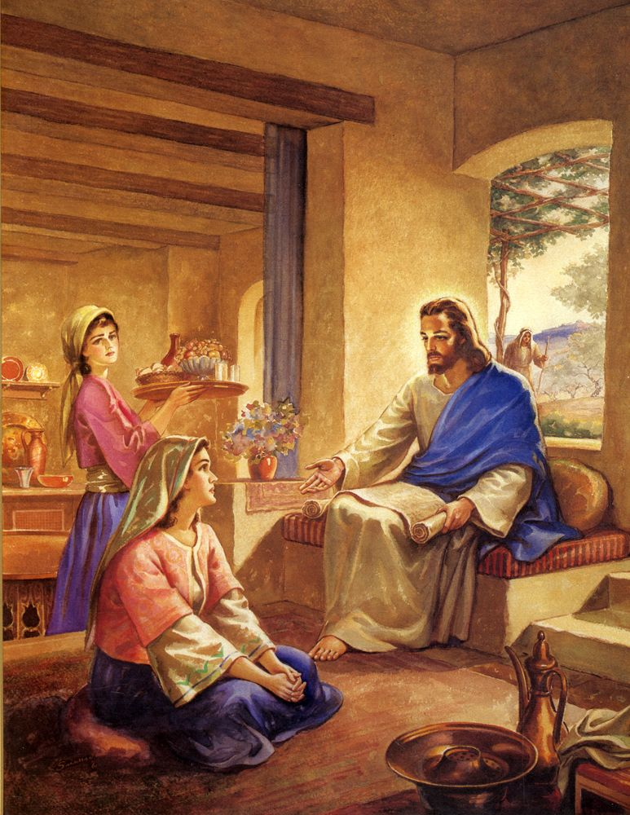

Luke_10:42 But one thing is needful: and Mary hath chosen that good part, which shall not be taken away from her.

